



Ch1 - Packet Tracer Skills Integration Instructions

# Topology Diagram

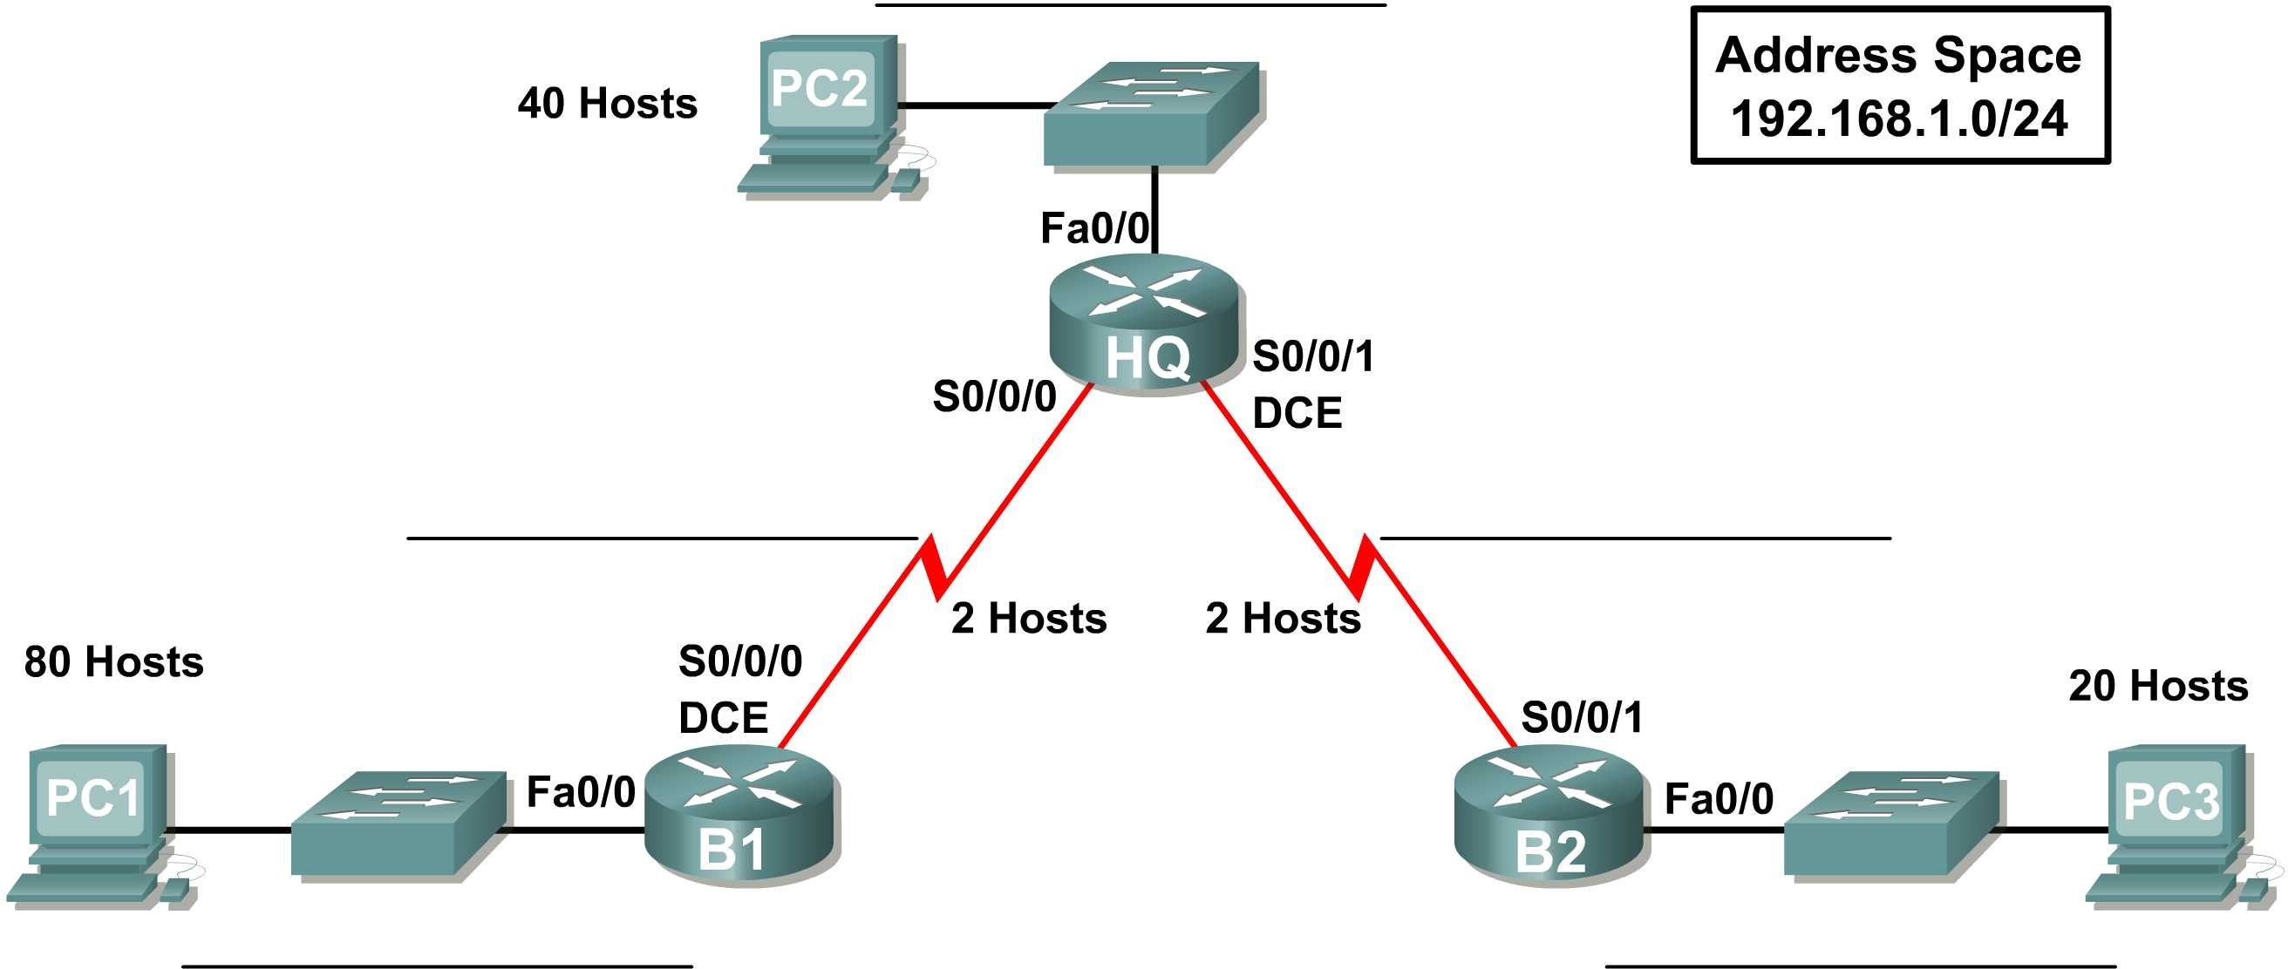

**Addressing Table**

|  |  |  |  |  |
| --- | --- | --- | --- | --- |
| **Device** | **Interface** | **IP Address** | **Subnet Mask** | **Default Gateway** |
| **HQ** | **Fa0/0** | 192.168.1.129 | 255.255.255.192 | **N/A** |
| **S0/0/0** | 192.168.1.225 | 255.255.255.252 | **N/A** |
| **S0/0/1** | 192.168.1.229 | 255.255.255.252 | **N/A** |
| **B1** | **Fa0/0** | 192.168.1.1 | 255.255.255.128 | **N/A** |
| **S0/0/0** | 192.168.1.226 | 255.255.255.252 | **N/A** |
| **B2** | **Fa0/0** | 192.168.1.193 | 255.255.255.224 | **N/A** |
| **S0/0/1** | 192.168.1.230 | 255.255.255.252 | **N/A** |
| **PC1** | **NIC** | 192.168.1.2 | 255.255.255.128 |  |
| **PC2** | **NIC** | 192.168.1.130 | 255.255.255.192 |  |
| **PC3** | **NIC** | 192.168.1.194 | 255.255.255.224 |  |

**Objectives**

* Design and document an addressing scheme based on requirements.
* Select appropriate equipment and cable the devices.
* Apply a basic configuration to the devices.
* Verify full connectivity between all devices in the topology.
* Identify layer 2 and layer 3 addresses used to switch packets.

## Task 1: Design and document an addressing scheme.

### Step 1: Design an addressing scheme.

Based on the network requirements shown in the topology, design an appropriate addressing scheme.

* Starting with the largest LAN, determine the size of each subnet you will need for the given host requirement.
* After the addresses have been determined for all the LAN subnets, assign the first available address space to the WAN link between B1 and HQ.
* Assign the second available address space to the WAN link between HQ and B2.

(**Note:** Remember that the interfaces of network devices are also host IP addresses and are included in the above addressing requirements.)

### Step 2: Document the addressing scheme.

* Use the blank spaces on the topology to record the network addresses in dotted-decimal/slash format.
* Use the table provided in the printed instructions to document the IP addresses, subnet masks and default gateway addresses.
  + For the LANs, assign the first IP address to the router interface. Assign the last IP address to the PC
  + For the WAN links, assign the first IP address to HQ.

## Task 2: Select equipment and cable devices.

### Step 1: Select the necessary equipment.

Select the remaining devices you will need and add them to the working space inside Packet Tracer. Use the labels as a guide as to where to place the devices.

### Step 2: Finish cabling the devices.

Cable the networks according to the topology taking care that interfaces match your documentation in Task 1.

## Task 3: Apply a basic configuration.

### Step 1: Configure the routers.

Using your documentation, configure the routers with basic configurations including addressing. Use

**cisco** as the line passwords and **class** as the secret password. Use 64000 as the clock rate.

### Step 2: Configure the PCs.

Using your documentation, configure the PCs with an IP address, subnet mask, and default gateway.

## Task 4: Test connectivity and examine the configuration.

### Step 1: Test connectivity.

RIP routing has already been configured for you. Therefore, you should have end-to-end connectivity.

* Can PC1 ping PC2? Yes
* Can PC1 ping PC3? Yes
* Can PC3 ping PC2? Yes Troubleshoot until pings are successful.

### Step 2: Examine the configuration.

Use verification commands to make sure your configurations are complete.

**Task 5: Identify layer 2 and layer 3 addresses used to switch packets.**  
**Step 1: Create a simple PDU ping packet**  
• Enter Simulation Mode.  
• Use the Add Simple PDU button to create a ping from PC1 to PC3.  
• Change “Edit Filters” so that only ICMP is simulated.  
**Step 2: Addresses at PC1**  
Record the addresses used by PC1 to send the ping packet to B1:  
Layer 3 Source: 192.168.1.2  
Layer 3 Destination:192.168.1.1  
Layer 2 Source: 0002.1627.55E0  
Layer 2 Destination: 00E0.B0E6.9CA9  
**Step 3: Addresses at B1**  
Record the addresses used by B1 to switch the ping packet to HQ:  
Layer 3 Source: 192.168.1.226  
Layer 3 Destination: 192.168.1.225  
Layer 2 Source:   
Layer 2 Destination:   
**Step 4: Addresses at HQ**  
Record the addresses used by HQ to switch the ping packet to B2:  
Layer 3 Source: 192.168.1.229  
Layer 3 Destination: 192.168.1.330  
Layer 2 Source:   
Layer 2 Destination:   
**Step 5: Addresses at B2**  
Record the addresses used by B2 to switch the ping packet to PC3:  
Layer 3 Source: 192.168.1.193  
Layer 3 Destination: 192.168.1.194  
Layer 2 Source: 0007.EC79.E032.  
Layer 2 Destination: 0005.5E97.C572